MINISTRY OF EDUCATION  AND TRAINING | NATIONAL INSTITUTE OF NUTRITION
CENTER FOR FOOD AND NUTRITION TRAINING

TRẦN CHÂU QUYÊN

DEVELOPMENT AND VALIDATION OF HEIGHT
AND WEIGHT ESTIMATION FOR HOSPITALIZED ELDERLY FROM CERTAIN HOSPITALS DURING
THE PERIOD 2018 - 2022

Specialization: Nutrition
Code: 9720401

SUMMARY OF DOCTORAL DISSERTATION

HANOI - 2023
THIS WORK WAS COMPLETED
at the National Institute of Nutrition

Academic Advisor:
1. Nghiem Nguyet Thu, MD., PhD
2. Prof. Pham Thang, MD.,PhD

Reviewer 1: ................
Reviewer 2:.................
Reviewer 3: ................

The thesis will be defended at the Institute-level doctoral thesis grading committee at the National Institute of Nutrition
At the hour, day month year 2023

The thesis can be found at:
-Vietnam National Library
- Library of the National Institute of Nutrition

INTRODUCTION

Weight and height represent fundamental criteria for nutrition care process. When elderly individuals are unable for conventional measurements, it's crucial to estimate using formulas.
The project entitled "Development and validation of height and weight estimation for hospitalized elderly from certain hospitals during the period 2018 to 2022" aim to streamline clinical processes and provide a convenient tool for medical staff.
OBJECTIVE
1. 'Development and validation of height estimation for hospitalized elderly from certain hospitals during the period 2018 to 2022.
2. 'Development and validation of weight estimation for hospitalized elderly from certain hospitals during the period 2018 to 2022.
3. Establish technical procedure for estimating the height and weight of elderly patients to facilitate the provision of nutritional care, utilizing formulas developed from certain hospitals during the period 2018 to 2022.
THE NOVEL CONTRIBUTIONS
This study marks the first attempt to create a set of formula for height and weight estimation using anthropometric characteristics of Vietnamese elderly within hospital setting. Subsequently, this leads to the creation of lookup tables and the technical procedures for guiding the estimation of height and weight in case of elderly individuals unable to assume conventional measurements.
THE ORGANIZATION OF THE THESIS
The complete thesis consists of 129 pages, featuring: Introduction (2 pages), Literature review (33 pages), Methodology (25 pages), Results (40 pages), Discussion (26 pages), Conclusion and Recommendations (3 pages). Additionally, the thesis incorporates 32 tables, 19 figures, and 111 references (in both English and Vietnamese).

Chapter 1
LITERATURE REVIEW

  - Terminology
    - Elderly
In Vietnam, the Law on Elderly stipulates Elderly people are Vietnamese citizens aged 60 years or older.

1.1.2. Elderly patients
The term "elderly patients" in this report is understood as elderly people using health care services.
1.2. Malnutrition in hospitalized elderly
1.3. Issues affecting anthropometric measurements in the elderly
- Age
- Gender
- Changes in bone structure
- Changes in body composition
1.4. Height estimation
1.4.1. Anthropometric measurement
1.4.2. Study population
1.4.3. Study algorithm
1.4.4. Anthropometric measurement utilized in height estimation development
- Height measurement
- Utilized anthropometric measurements: knee height, sitting height, the length of humerus, arm span, femur, radius bone, tibia, fibula.
1.5. Weight estimation
1.5.1. Anthropometric measurement
1.5.2. Study population
1.5.3. Study algorithm
1.5.4. Anthropometric measurement utilized in weight estimation development
- Weight measurement
- Utilized anthropometric measurement: the circumference of arm, calf, chest, waist;, subcutaneous fat thickness, height and knee height.
1.5. Challenges in the application of anthropometric data and strategies for error mitigation
1.6.1. Measurement technique
1.6.2. Multicollinearity
1.7. The application of techniques for estimating height and weight
Globally, several screening guidelines for malnutrition including practical tools like the MUST (Malnutrition Universal Screening Tool) and the MNA-SF (Mini Nutritional Assessment - Short Form) have been developed. Currently in Vietnam, there is no formalized method or procedure for the puroposed of estimating the height and weight of elderly individuals using specific data of Vietnamese elderly.
  - Problem statement and expected outcome
1.8.1. Problem statement: The elderly population is growing rapidly. Morbidity and risk of malnutrition as well as medical situations make compliance with traditional weight and height. Most hospitals are not equipped with bed scales due to the cost and manpower involved in performing this routinely.
1.8.2. Expected outcome: Develop and validate weight and height estimation for hospitalized elderly that meets scientific requirements and is applicable in daily clinical practice.
  - Description of study area
- Equation development: at National Geriatric hospital Vietnam, an extensive national healthcare, with profesional human resources and facilities for standardized anthropometric measurement since 2018.
- Equation validation: utilized data from the Elderly Health screening program organized by National Geriatrics hospital incorporation with Khanh Hoa Provincial General hospital and Quy Nhon General hospital in 2019.
- Equation validation in critical ill elderly: at Intensive care unit center, Bach Mai hospital (2022), ultilized routine anthropometric database.

Chapter 2
METHODOLOGY
The study variables in this study are defined as follows:
- Age: in years, chronological age
- Height (H): conventional height measurements
- Estimated height (EH): the height identified by estimation formula
- Weight (W): conventional weight measurements
- Estimated weight (EW): the weight identified by estimation formula
- Humerus length (HL): is the length determined from the acromion of the humerus to the elbow
- Knee height (KH): is the distance from the upper edge of the patella to the ground (sitting position) or to the heel at the surface of the foot in a direction perpendicular to the lower leg (lying position).
- Mid arm circumference (MAC): is the circumference through the plane at the midpoint of the humerus.
- Calf circumference (CC): is the circumference at the widest position of the calf when the leg is straight and the lower leg is perpendicular to the foot.
The collected data gathered adheres to international standards and anthropometric measurements methodologies for the adults and elderly.
This study was approved by the Council of Ethics in Biomedical Research in Decision No. 505/VD-QLKH dated October 17, 2018.

Formular development | - Ambulatory elderly  - National Geriratric hospital Vietnam  - From October 2018 to April 2021.  - Technical measurement agreement using technical error of measurement (TEM) and Relative TEM | Anthropometric measurement selection  (Age, HL, KH, MAC, CC)  ⇓  Correlation analysis  ⇓  Linear regression analysis | - Test for normal distribution  - Comparison between two groups (men and women)  - Correlation analysis  - Univariate linear regression analysis, create the fomular in the form of y = a +bx  - Multivariate linear regression analysis, create the fomular in the form of y = a + bx₁ + cx₂  where a, b, c are regression coefficients; xi are independent variables; y is the dependent variable.
Formular validation | - Quy Nhon City and Khanh Hoa Province General Hospital: Ambulatory elderly  - Bach Mai hospital: non- ambulatory elderly | Formular validation at General hospital  ⇓  Formular validation in critical ill non- ambulatory elderly  ⇓  Recommendation and Lookup table | Formular validation:  - Bland- Altman plots  - Analyse the margin of error of 10% with weight estimation formula  - Develop lookup table
Application | National Institute of Nutrition Vietnam | ⇓  Establish technical procedure for estimating the height and weight of elderly patients | - Estimate weight and height for elderly patients by lookup table  - Establish technical procedure for estimating the height and weight of elderly patients

Chapter 3
RESULT
3.1. Formular development
3.1.1. Anthropometric characteristics
Table 3.1. Anthropometric characteristics of the formular development group
Variable | General  (n = 539) | Men  (n = 192) | Women  (n = 347) | p ^{b}
W (kg) | 47.9 ± 9.6 ª | 52.5 ± 9.1 ª | 45.3 ± 8.8 ª | 0.00
H (cm) | 151.1 ± 8.7 ª | 158.4 ± 7.0ª | 147.1 ± 6.7 ª | 0.00
MAC (cm) | 25.2 (23.3-27.0) | 25.6 ± 3.0 ª | 25.0 ± 3.4 ª | < 0.05
CC (cm) | 30.2 ± 3.4 ª | 31.3 ± 2.8 ª | 29.6 ± 3.5 ª | 0.00
HL (cm) | 25.0 (22.3-31.2) | 26.5 (24.0-32.5) | 24.0 (21.5-30.5) | < 0.05
KH (cm) | 43.7 ± 3.4 ª | 45.9 ± 2.9 ª | 42.9 (40.9-44.6) | 0.00
Age (year) | 80.0 (68.0-84.0) | 80.0 (69.0-84.0) | 81.0 (67.0-84.0) | < 0.05
SD (Standard deivation); BMI (body mass index); W: weight; H; height; MAC: Mid arm circumference; CC: Calf circumference; HL: humeruos lenght; KH: Knee height.
^{a:} Data in mean ± SD; ^{a:} Data in median (quartile range); p: collected from Student–T test or Mann–Whitney U test.
Based on the differences in anthropometric characteristics between men and women, all data were separated by 2 genders for further analysis.
3.1.2. Develop height estimation equation
3.1.2.1. Correlation analysis
Using Pearson correlation analysis to test the correlation between height and age, MAC, CC, HL and KH, the results are shown in Table 3.2 as follows.
Table 3.2. Correlation between height and independent variables
Correlation | Men (n =192) | Women (n = 347)
Age-H | -0.336 ^{**b} | -0.502 ^{**c}
MAC- H | 0.215^{**a} | 0.298^{**a}
CC- H | 0.278^{**a} | 0.530^{**c}
HL- H | 0.418^{**b} | 0.554^{**c}
KH- H | 0.643^{**c} | 0.590^{**c}
H; height; MAC: Mid arm circumference; CC: Calf circumference; HL: humeruos lenght; KH: Knee height.
**: The correlation is statistically significant at p < 0,01; a: weak (r < 0.3); b: moderate weak (0.3 ≤ r < 0.5); c: moderate strong (0.5 ≤ r < 0.7).
3.1.2.2. Linear regression analysis and equation creation in men
Table 3.3. Univariate linear regression analysis to assess the impact of independent variables on height in men
Variable | B | r² | Adj r² | SEE | p
(Const) | 178.463 | 0.113 | 0.109 | 6.419 | 0.00
Age | -0.260 |  |  |  | 0.00
(Const) | 145.589 | 0.046 | 0.041 | 6.812 | 0.00
MAC | 0.499 |  |  |  | 0.00
(Const) | 143.958 | 0.175 | 0.170 | 6.185 | 0.00
HL | 0.520 |  |  |  | 0.00
(Const) | 136.788 | 0.078 | 0.073 | 6.700 | 0.00
CC | 0.690 |  |  |  | 0.00
(Const) | 88.201 | 0.413 | 0.410 | 5.177 | 0.00
KH | 1.529
*: t test (student) statistically significant at p < 0.01; Const: Constant; Adj: Adjusted; SEE: Standard Error of the Estimates; MAC: Mid arm circumference; CC: Calf circumference; HL: humeruos lenght; KH: Knee height.
Equation to estimate height in men using univariate linear regression analysis:
EH₁ = 1.529 x KH + 88.201 (r² = 0.413; SEE = 5.343) where EH: estimated height (cm); KH: Knee height (cm).
Table 3.4. Multivariate linear regression analysis to assess the impact of independent variables on height in men
Variable | B | r² | Adj r2 | SEE | p
(Const) | 106.816 | 0.471 | 0.465 | 4.949 | 0.00
KH | -0.188 |  |  |  | 0.00
Age | 1.440 |  |  |  | 0.00

*: t test (student) statistically significant at p < 0.01; Const: Constant; Adj: Adjusted; SEE: Standard Error of the Estimates; KH: Knee height (cm).
Equation to estimate height in men using multivariate linear regression analysis:
EH ₂ = -0.188 x Age + 1.440 x KH + 106.816 (r² = 0.471; SEE = 5.087), where EH: estimated height (cm); KH: Knee height (cm).
3.1.2.3. Linear regression analysis and equation development in women
Perform similar analyzes in men, the equation to estimate height in women using univariate linear regression analysis is:
EH 1 = 0.657 x HL + 130.322 (r² = 0.307; SEE = 5.454)
Emphasizing the prioritization to clinical suitability, considering that the extra variables had only minor effects on the model's outcome, the selected formulas for further hospital validation:
EH ₂ = 0,410 x HL + 0,928 x KH + 97,162 (r² = 0,438; SEE = 4,890)
EH ₃ = -0,259 x Age + 1,103 x KH + 120,292 (r² = 0,482; SEE = 4,701)
where EH: estimated height (cm); HL: Humeruos lenght (cm); KH: Knee height (cm)
3.1.3. Develop weight estimation equation
3.1.3.1. Correlation analysis
The result as in Table 3.7:
Table 3.7. Correlation between weight and independent variables

Correlation | Men (n =192) | Women (n = 347)
Tuổi- CN | -0.302^{**b} | -0.540^{**b}
VCT- CN | 0.785^{**d} | 0.748^{**d}
VBC- CN | 0.762^{**d} | 0.803^{**d}
DCT- CN | 0.377^{**b} | 0.529^{**c}
CĐG- CN | 0.419^{**b} | 0.405^{**b}

W: Weight; MAC: Mid arm circumference; CC: Calf circumference; HL: humeruos lenght; KH: Knee height.
**: The correlation is statistically significant at p < 0,01; *: The correlation is statistically significant at p < 0.05; a: weak (r < 0,3); b: moderate weak (0.3 ≤ r < 0.5); c: moderate strong (0.5 ≤ r < 0.7); d: strong correlation (p ≥ 0.7)

3.1.3.2. Linear regression analysis and equation development in men
Equations to estimate weight in men based on univariate linear regression analysis:
EW₁ = 2.379 x MAC - 8.527 (r² = 0.616; SEE = 5.666)
EW₂ = 2.471 x MAC - 24.874 (r² = 0.580; SEE = 5.924)
Highlighting the focus on clinical feasibility, considering that the extra variables had only minor effects on the model's outcome, the selected formulas for further hospital validation:
EW ₁ = 2.379 x MAC - 8.527 (r² = 0.616; SEE = 5.666)
EW ₂ = 2.471 x CC - 24.874 (r² = 0.580; SEE = 5.924)
EW ₃ = 1.507 x MAC + 1.381 x CC - 29.401 (r² = 0.711; SEE = 4.899)
Where: EW: estimated weight; MAC: Mid arm circumference; CC: Calf circumference.
3.1.3.3. Linear regression analysis and equation development in women
Equations to estimate weight in women using univariate linear regression analysis:
EW = 2.016 x CC – 14.419 (r² = 0.644; SEE = 5.267)
Emphasizing the prioritization to clinical suitability, considering that the extra variables had only minor effects on the model's outcome, the selected formulas for further hospital validation:
EW ₁ = 2.016 x CC – 14.419 (r² = 0.645; SEE = 5.267)
EW ₂ = 0.987 x MAC + 1.374 x CC - 20.090 (r² = 0.721; SEE = 4.675)
Where: W: Measured weight; MAC: Mid arm circumference; CC: Calf circumference.
3.2. Hospital validation
3.2.1. Hospital validation of height estimation equation
3.2.1.1. Hospital validation of height estimation equation in men
(A) Height estimation 1 = 1.529 x KH + 88.201  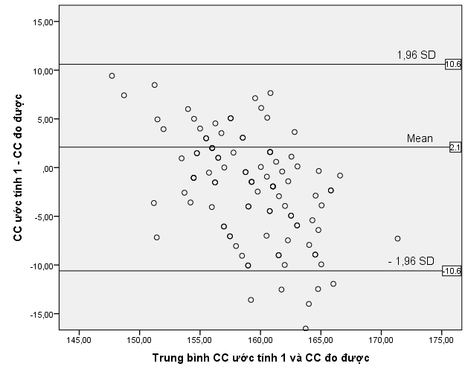 | (B) Height estimation 2 = - 0.188 x Age + 1.440 x KH + 106.816  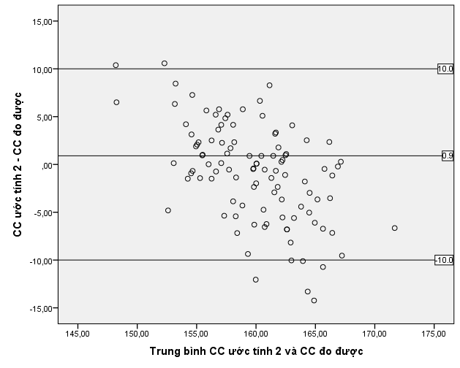
Figure 3.1. Bland- Altman plots to assess the agreement between estimation height and measured height in men
Figure 3.1 showed that both these two estimates had > 90% of plots within ± 1.96SD, showing that the estimate height was agreement with the measured height.
3.2.1.2. Hospital validation of height estimation equation in women
Similary to the results in men, Bland- Altman plots analysis the height estimation in women showed both height estimation using combination of KH and HL (EH₂ = 0.410 x HL + 0.928 x KH + 97.162), and the height estimation based on age and KH (EH₃ = -0.259 x Age + 1.103 x KH + 120.292) had > 90% of plots within ± 1.96SD, showing that the estimate height was agreement with the measured height.
3.2.1. Hospital validation of weight estimation equation
3.2.1.1. Hospital validation of weight estimation equation in men
Table 3.20. Comparison of estimated weight and measured weight in men
Type of weight | Mean  (mean ± SD) | Difference*  (mean ± SD) | 95%CI | p*
W (kg) | 58.0 ± 10.5
EW1 (kg) | 56.2 ± 6.9 | - 1.8 ± 5.8 | - 2.9 ; 0.7 | 0.00
EW 2 (kg) | 57.0 ± 8.1 | - 1.1 ± 5.4 | - 2.1; 0.0 | 0.05
EW 3 (kg) | 57.3 ± 8.5 | - 0.7 ± 4.6 | - 1.6 ; -0.2 | 0.14
W: Measured weight; EW: Estimated weight
* Difference = estimated weight – measured weight
EW₁ (kg) = 2.379 x MAC (cm) - 8.527
EW₂ (kg) = 2.471 x CC (cm) - 24.874
EW₃ (kg) = 1.507 x MAC (cm) + 1.381 x CC (cm) - 29.401
The negative difference values indicated that the estimated weight was lower than the measured weight; the result of estimated weight 3 were not statistically difference compared to the measured weight.
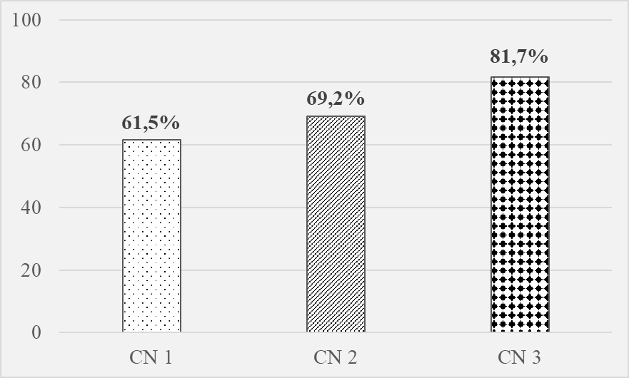 | Figure 3.3. The percentage of elderly patients with margin of errors < 10% in men
3.2.1.2. Hospital validation of weight estimation equation in women
Table 3.22. Comparison of estimated weight and measured weight in women
Type of weight | Mean  (mean ± SD) | Difference*  (mean ± SD) | 95%CI | p*
W (kg) | 54.0 ± 9.9
EW₁ (kg) | 50.6 ± 6.7 | - 3.4 ± 6.4 | -4.3; -2.5 | 0.00
EW₂ (kg) | 51.4 ± 6.8 | - 2.6 ± 5.7 | -3.4; -1.8 | 0.00
W: Measured weight; EW: Estimated weight
* Difference = estimated weight – measured weight
EW₁ (kg) = 2.016 x CC (cm) - 14.419
EW₂ (kg) = 0.987 x MAC (cm) + 1.374 x CC (cm) - 20.090
The negative difference values indicated that the estimated weight was lower than the measured weight; both of the two estimated weights were statistically difference compared to the measured weight.
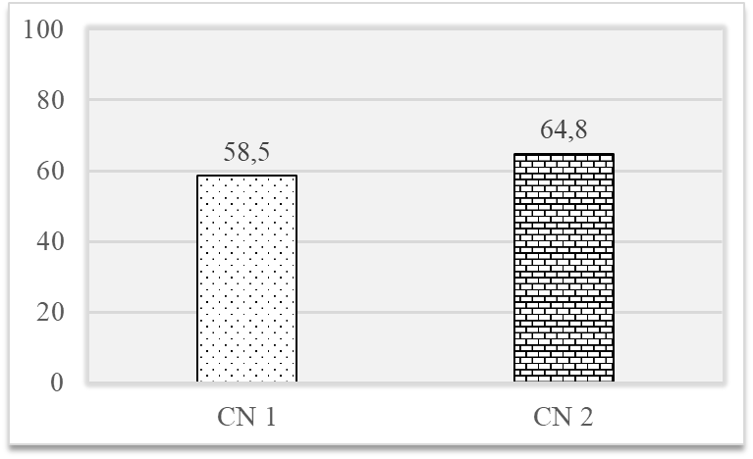
Figure 3.5. The percentage of elderly patients with margin of errors < 10% in women
3.3. Hospital validation of weight estimation equation in critical ill elderly
3.3.1. Hospital validation of weight estimation equation in critical ill elderly men
Table 3.25. Comparison of estimated weight and measured weight in men
Type of weight | Mean  (mean ± SD) | Difference*  (mean ± SD) | 95%CI | p*
W (kg) | 58.3 ± 12.2
EW1 (kg) | 53.3 ± 8.6 | - 5.0 ± 7.5 | - 7.7 ; 2.3 |  | 0.00
EW 2 (kg) | 49.3 ± 10.9 | - 9.0 ± 10.0 | - 12.7 ; 5.3 |  | 0.00
EW 3 (kg) | 51.3 ± 10.8 | - 7.1 ± 8.1 | - 10.1; 4.1 |  | 0.00
W: Measured weight; EW: Estimated weight
* Difference = estimated weight – measured weight
EW₁ (kg) = 2.379 x MAC (cm) - 8.527
EW₂ (kg) = 2.471 x CC (cm) - 24.874
EW₃ (kg) = 1.507 x MAC (cm) + 1.381 x CC (cm) - 29.401
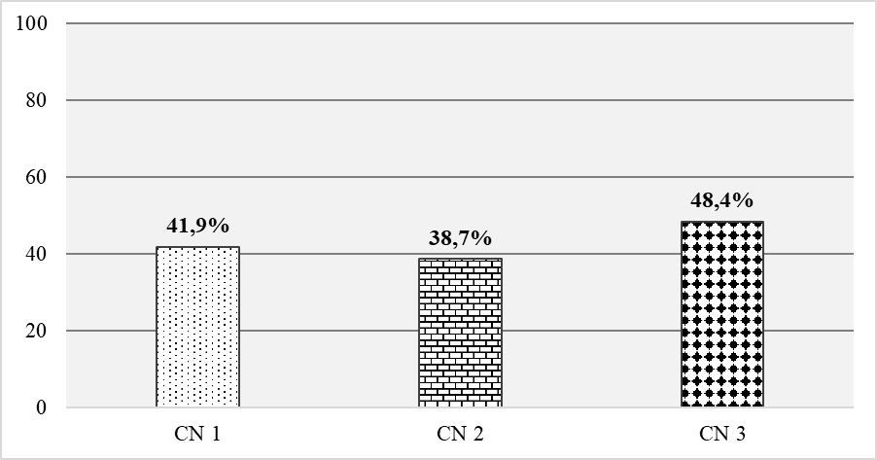
Figure 3.7. The percentage of elderly patients with margin of errors < 10% in men
3.3.1. Hospital validation of weight estimation equation in critical ill elderly women
Table 3.26. Comparison of estimated weight and measured weight in women
Type of weight | Mean  (mean ± SD) | Difference*  (mean ± SD) | 95%CI | p*
W (kg) | 50.8 ± 10.9
EW₁ (kg) | 43.0 ± 8.1 | -7.8 ± 6.2 | -10.1 ; -5.7 |  | 0.00
EW₂ (kg) | 44.5 ± 8.9 | -6.4 ± 5.6 | -8.3 ; -4.4 |  | 0.00
W: Measured weight; EW: Estimated weight
* Difference = estimated weight – measured weight
EW₁ (kg) = 2.016 x CC (cm) - 14.419
EW₂ (kg) = 0.987 x MAC (cm) + 1.374 x CC (cm) - 20.090
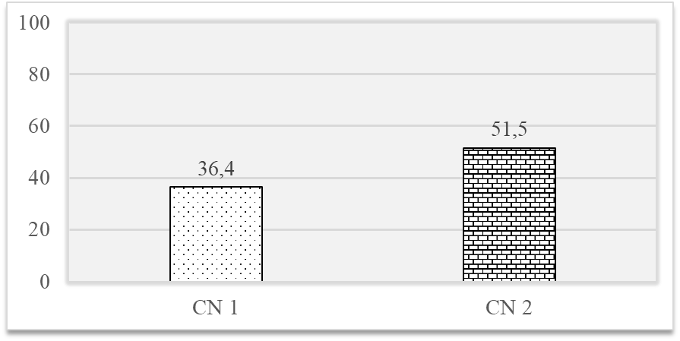
Figure 3.9. The percentage of elderly patients with margin of errors < 10% in women
3.4. Results of lookup table creation
3.4.1. Height estimation lookup table
3.4.1.1. Lookup table for estimating men's height
The lookup table was created according to the equation:
Estimated height (cm) = - 0.188 x Age + 1.440 x KH (cm) + 106.816
Retrieve data called "Height estimation lookup table for men using age and knee height".
3.4.1.2. Lookup table for estimating women's height
The table was generated based on the following equation:
Estimated height (cm) = - 0.259 x Age + 1.103 x KH (cm) + 120.292
In case of age was not well defined. the following equation instead:
Estimated height (cm) = 0.410 x HL (cm) + 0.928 x KH (cm) + 97.162
Acquired data showed in "Height estimation lookup table for women using age and knee height", and "Height estimation lookup table for women using humeruous lenght and knee height", respectively.
3.4.2. Weight estimation lookup table
3.4.2.1. Lookup table for estimating men's weight
The table was derived utilizing the subsequent equation:
Estimated weight (kg) = 1.507 x MAC (cm) + 1.381 x CC (cm) - 29.401
Access data from "Weight estimation lookup table for men using mid arm circumference and calf circumference".
3.4.2.2. Lookup table for estimating women's weight
The table was derived according to equation:
Estimated weight (kg) = 0.987 x MAC (cm) + 1.374 x CC (cm) - 20.090.
Obtain data from "Weight estimation lookup table for women using mid arm circumference and calf circumference".
3.5. The technical procedure for estimating the height and weight of elderly patient utilizing developed and validated fomular
- The technical procedure for estimating elderly's height
- The technical procedure for estimating elderly's weight.
Chapter 4
DISCUSSION
4.1. Discussion on height estimation equation
4.1.1. Variable selection
4.1.1.1. Age
Global research has revealed that age exerts an influence on stature; however, this influence varies significantly between genders and across various age groups. In other terms, the effect of age on each model used to formulate height estimation exhibits variation. In our investigation, both men and women exhibited a negative Pearson correlation coefficient (r = -0.336 for men and r = -0.502 for women). This indicates a negative correlation between age and height, signifying that as age increases, height tends to decrease. This trend is more manifest in women compared to men, possibly attributable to women experiencing an earlier onset of osteoporosis and a faster rate of decline, influenced by endogenous osteoporosis factors and estrogen hormone levels. These findings align with studies conducted in Thailand, corroborating the idea that the inclusion of age improves the precision of the formula.
4.1.1.2. Knee height
It was wellknown that knee height is an age-independent factor and did not decrease over time. In this study, the Pearson correlation coefficient between knee height and age was weakly correlated (r = - 0.154 and r = - 0.248 in men and women, respectively). When included in the linear model to evaluate the the impact of knee height (as an independent variable) on height (dependent variable), the impact of knee height on height in men and women were r² = 0.413 and r² = 0.132, respectively. Knee height has a stronger impact on the height estimation model in men than in women. Compared to Chumlea WC (1992)'s research, the results of this study were lower (with r² ranging from 0.51 to 0.70). This indicated that the straightforward influence of knee height on stature in both men and women varies across different populations. This variability may elucidate why the application of height estimation equations in different population gived dissimilar results.
4.1.1.3. Humerous lenght
In comparison to research utilizing humerus length as a variable to estimated height, studies employing knee height for this purpose were less prevalent. Some studies conducted in Thailand have indicated that humeral length could serve as a valuable metric for height estimation. In the current investigation, the Pearson correlation between humerous length and measured height showed a correlation coefficient of r = 0.418 for men and r = 0.554 for women. When juxtaposed with the correlation between knee height and height (r = 0.643 in men and r = 0.590 in women), it becomes evident that humerous length exhibits a stronger correlation with height in women than in men, in contrast to knee height, which demonstrates a stronger correlation in men than in women.
4.1.2. Results on height estimation equation development and validation
Worldwide and Vietnamese studies have generated diverse height estimation formulas, with variations in population profiles, sample sizes, variables, and methodologies, each possessing distinct strengths and weaknesses. This study intentionally selected relevant indicators. Data from hospitals may not fully represent the wider community. This marks the first effort to create a height estimation equation for elderly individuals in Vietnam. Notably, this study lacks ethnic diversity, which is significant as different ethnic groups may have distinct anthropometric characteristics.
Transitioning to the validation phase, despite the rounding of anthropometric measurements to 1cm instead of the standard 1mm precision, these formulas are applicable for estimating the height of elderly individuals in real-world clinical settings in Vietnam.
Analysis of Bland-Altman plots indicates that over 90% of the plots fall within the ± 1.96 standard deviation range, confirming the consistency of the height estimates with the measured height. Furthermore, when the formula was validated at a different population in another location, the estimated height remained consistent with the measured height, suggesting its appropriateness for clinical use in Vietnam.
4.2. Discussion on height estimation equation
4.2.1. Variable selection
4.2.1.1. Age
Previous research has revealed that anthropometric measurement exhibits varying characteristics across different age groups. The incorporation of age into the weight estimation models was contingent upon the characteristics of the research population. In this study, when age was incorporated into the linear regression model, it only marginally increased the regression coefficient (r-squared) for both men and women. Therefore, it is recommended that simplifying clinical application weight estimation should omit the age.
4.2.1.2. Mid arm circumference and calf circumference
The results of this study show that in both genders, the combination of MAC and CC gived the model's regression coefficient > 70% and adding the indicators age, HL, and KH helped slightly increase the accuracy. These findings align with the results reported in several prior studies.
4.2.2. Results on weight estimation equation development and validation
This is the first study to formulate a weight estimation equation tailored to elderly in Vietnamese hospital settings, adopting the research methodology established by Chumlea and colleagues in 1988. In the referenced study, the regression coefficient r-squared (r²) ranged from 0.82 to 0.85, underscoring that arm circumference and calf circumference collectively accounted for over 80% of the weight model. In our investigation, the weight model incorporating age, MAC, CC and KH achieved an 80.3% impact in men's height estimation, while in women, the combination of age, MAC and KH only achieved a 69.6% impact on the model.
Additionally, in comparison to the previously developed formulas incorporating MAC, CC and KH, the weight estimation model in this study exhibits the lowest contribution to the weight calculation model, in terms of the percentage explained (as indicated by the r-squared coefficient).
At validation stage, in men, the MAC and CC-based equation achieved higher accuracy, with 81.7% within ±10% acceptable margin of error, outperforming Ross Laboratory's MAC and KH-based formula. Women had a lower accuracy rate of 64.8%, consistent with other formula comparisons.
4.2.3. Results on weight estimation equation validation in critical ill elderly
In men, the acceptable margin of error within ±10% of equation based on MAC and CC (EW₃) was only 48.4% in men and 51.5 in women. These findings align with previous research outcomes. Notably, muscle mass loss is a critical concern for critical ill elderly. While there is limited research on changes in body mass index during critical illness, M. T. Izquierdo Fuentes has noted that patients undergoing intensive resuscitation treatment experience significant muscle mass loss and an elevated fat mass rate during the initial week of treatment. The process of intensive resuscitation poses a challenge for medical personnel, as it exacerbates factors leading to muscle atrophy. The combination of immobilization and acute illness accelerates the loss of muscle mass.
In immobilized conditions, coupled with acute illness, the elderly experience rapid muscle mass loss, detectable as early as the 3rd day, with a typical decline of about 14% to 21% during the initial week of intensive care. These findings are consistent with Maskin LP's (2020) cautionary conclusion that using weight estimation formulas for critically ill patients must be approached with care, as they can lead to overestimation of weight, potentially resulting in higher-than-needed therapeutic doses and increased associated risks.
4.3. Discussion on the technical procedure for estimating the height and weight of elderly patient utilizing developed and validated fomular
This is the first technical procedure for estimating the height and weight of elderly patient of the Vietnam National Institute of Nutrition, aiming to standardize these procedures for practical implementation. This method serves as both a practical guideline and a foundational step towards standardizing the process to collect the data on height and weight in cases of elderly unable to have conventional measurements. These technical procedure ultilized equations that developed based on elderly patients, making it a promising prospect for becoming a standard practice in Vietnamese clinical settings.
CONCLUSION

1. Height estimation equation
For men:
EH₁ (cm) = 1.529 x KH (cm) + 88.201 (r² = 0.410; SEE = 5.177)
EH ₂ (cm) = - 0.188 x Age + 1.440 x KH (cm) + 106.816 (r² = 0.465; SEE = 4.949)
For women:
EH ₁ (cm) = 0.657 x HL (cm) + 130.322 (r² = 0.305; SEE = 5.454)
EH ₂ (cm) = 0.410 x HL (cm) + 0.928 x KH (cm) + 97.162 (r² = 0.434; SEE = 4.890)
EH₃ (cm) = - 0.259 x Age+ 1.103 x KH (cm) + 120.292 (r² = 0.479; SEE = 4.701)
Where: EH: estimated height (cm); HL: Humeruos lenght (cm); KH: Knee height (cm); SEE: Standard error of estimation (cm)
2. Weight estimation equation
For men:
EW₁ (kg) = 2.379 x MAC (cm) - 8.527 (r² = 0.616; SEE = 5.666)
EW ₂ (kg) = 2.471 x CC (cm) - 24.874 (r² = 0.580; SEE = 5.924)
EW ₃ (kg) = 1.507 x MAC (cm) + 1.381 x CC (cm) - 29.401 (r² = 0.714; SEE = 4.899)
For women:
EW ₁ (kg) = 2.016 x CC (cm) - 14.419 (r² = 0.644; SEE = 5.267)
EW ₂ (kg) = 0.987 x MAC (cm) + 1.374 x CC (cm) - 20.090 (r² = 0.720; SEE = 4.675)
Where: EW: Estimated weight; MAC: Mid arm circumference; CC: Calf circumference; SEE: Standard error of estimation (cm)
3. The look up tables on height, weight estimation and the technical procedure for estimating the height and weight of elderly patient.
RECOMMENDATION

1. The height estimaion equations in men were EH (cm) = 1,529 x KH (cm) + 88,201 or EH (cm) = - 0.188 x Age + 1.440 x KH (cm) + 106.816; in women were EH (cm) = 0.410 x HL (cm) + 0.928 x KH (cm) + 97.162 or EH (cm) = - 0.259 x Age + 1.103 x KH (cm) + 120.292. These equations can be applied in clinical practice.
2. The weight estimaion equations in men EW (kg) = 1.507 x MAC (cm) + 1.381 x CC (cm) - 29.401 and in women EW (kg) = 0.987 x MAC (cm) + 1.374 x CC (cm) - 20.090 can be applied in general clinical practice, but noted that the estimated results may be more prone to errors in women. However, it's advisable to restrict the use of these formulas to critically ill elderly.

LIST OF DISCLOSED RESEARCH RELATED
TO THE THESIS THEME

- Tran Chau Quyen, Nghiem Nguyet Thu, Pham Thang, Bui Thi Huong Lan,Vu Thi Thu Ha, Ngo Mai Phuong, Nguyen Lien Hanh (2023). Prevalence of elderly malnutrition and relation between body mass index and mid arm-, calf -circumference at National Geriatric hospital Vietnam. Vietnam Journal of Preventive medicine. 33(3).72-77.
- Tran Chau Quyen, Nghiem Nguyet Thu, Pham Thang, Nguyen Trung Anh, Tran Quang Binh, Ngo Mai Phuong, Nguyen Quy Phong (2023). Height estimation using upper arm length and knee height in Vietnamese elderly. Vietnam Journal of Preventive medicine. 33(3). 78-85.

